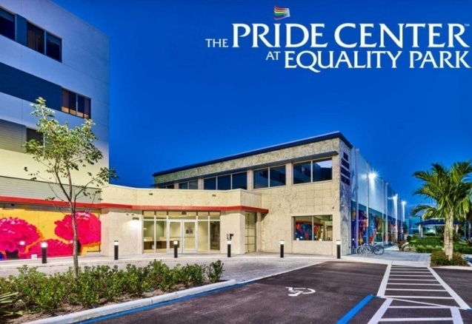
Registration Form South Florida Mustangs 50th Anniversary Gala

March 5 – 7, 2027
All the dancing will be held at the Price Center
2040 N. Dixie Hwy., Wilton Manors,
FL 33305.
Our callers will be
Chris Phillips and Darren Gallina.

Your information (one form per person)

Full Name: Address: City, State, Zip Club Affiliation:
Dance Level: ☐Mainstream ☐Plus ☐Advanced ☐C1 ☐C2 ☐Non Dancer

Email:
Phone:
Prices: $100.00 until January 1st, 2027
$115.00 January 2nd till April1st, 2027
$135.00 April 2nd till March 5th, 2027
$ 50.00 Non Dancer

Prices include dancing Friday, Saturday & Sunday. Continental breakfast Saturday and Sunday. Friday night Pizza. Sat. lunch on your own. Sat. night chef prepared dinner. Snacks throughout the day. And loads of free time fun in Wilton Manors, the heart of Gay Fort Lauderdale.

Payment via Check:
Make checks payable to South Florida Mustangs.
3001 S. Course Drive Suite 409
Pompano Beach, FL 33069

Payment via Zelle: Call Doug Kent at 305-495-2978 for phone
Reservation and funds transfer.

For more information:
www.Mustangs50thCelebration.org

